USER GUIDE FOR PRINTING ALIGNMENT OF PREPRINTED FORMS
- Paper Alignment
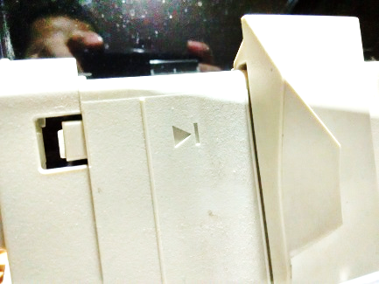
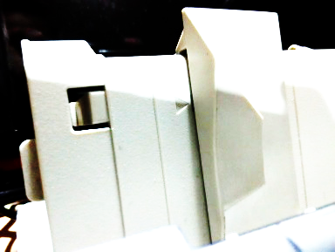
  - Align the paper guide to its base position.
BASE
CORRECTLY ALIGNED
WRONG ALIGNMENT

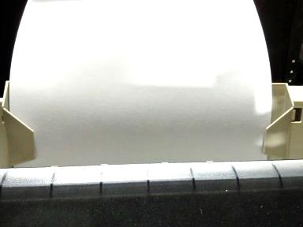
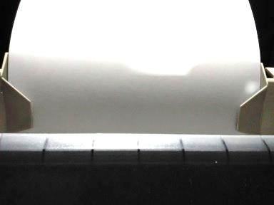
  - Adjust the paper guide according to paper size.
GAP
NO GAP
ALIGNED

ALIGNED
WRONG ADJUSTMENT
CORRECTLY ADJUSTED
- Printing from Adode Reader X (version 10 or latest).
  - Click the printer icon.
  - Choose your connected printer.
  - On the “Print” option window, choose “Actual Size” and check “Choose paper size by PDF page size”.
  - Click the “Print” button.
b.
a.
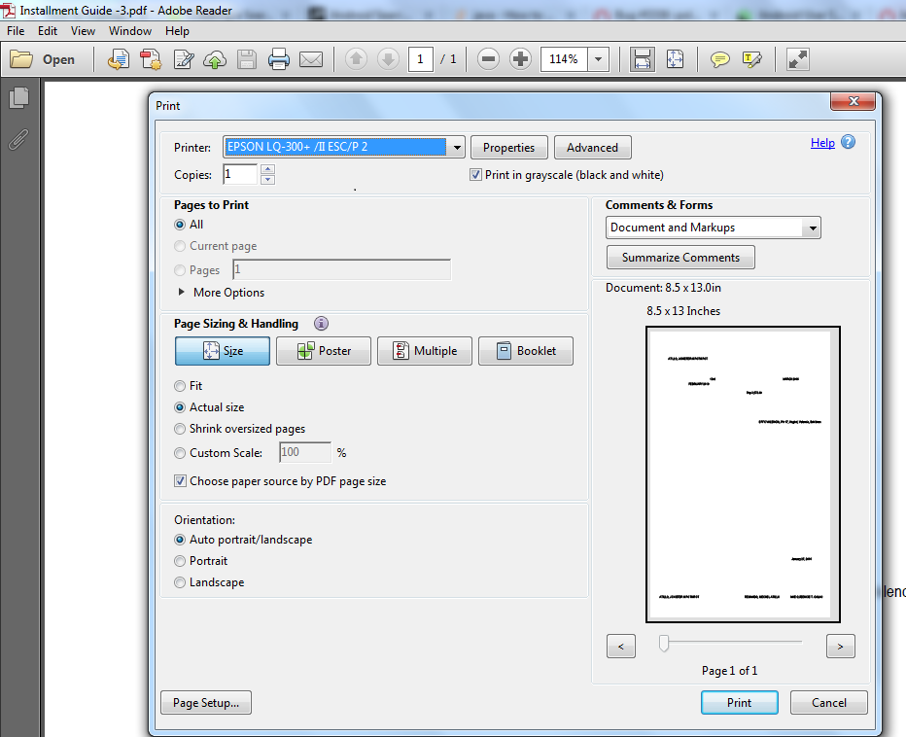
c.
d.

NOTE: If your “Print” option window does not look like the above image, Please inform the MIS Hardware immediately to upgrade your “Adobe Reader” to version 10.

